PL HW4
111261012
張晉瑜
Problem 1：
Code
1. #include <iostream>
2. #include <map>
3. using namespace std;
4. int main(){
5. int a[3];
6. /*原本想優化IO*/
7. // cin.tie(0);
8. // ios_base::sync_with_stdio(false);
9. cout<<"Input three sides of triangle: ";
10. while(cin>>a[0]>>a[1]>>a[2]){
11. map<int,int> ans;
12. for(int i=0;i<3;i++) ans[a[i]]++; //利用STL的map當作hash table
13. cout<<"This is an ";
14. switch(ans.size()){ //ans的size就是邊長種類的數量
15. case 1:
16. cout<<"Equilateral ";
17. break;
18. case 2:
19. cout<<"Isosceles ";
20. break;
21. case 3:
22. cout<<"Scalene ";
23. break;
24. }
25. cout<<"Triangle\nInput three sides of triangle: ";
26. }
27. }
28.
Output
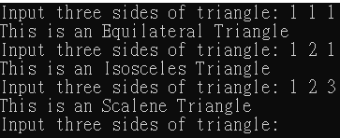

Problem 2：
Code
1. #include <iostream>
2. using namespace std;
3.
4. int main(){
5. int x,y;
6. cin>>x>>y; //input
7. cout<<"X\tY\tX+Y\tX-Y\tX*Y\n";
8. for(int i=0;i<4;i++){
9. for(int j=0;j<9;j++)
10. cout<<"-";
11. }
12. cout<<endl;
13. for(int i=x;i<=x+4;i++){
14. printf("%d\t%d\t%d\t%d\t%d\n",i,y,i+y,i-y,i*y);
15. y++;
16. }
17. }
18.
Output
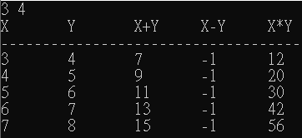
Problem 3：
Code
1. #include <iostream>
2. #include <vector>
3. #include <algorithm>
4. using namespace std;
5.
6. bool upper(int a,int b){ //sort by upper
7. return a<b;
8. }
9. bool lower(int a,int b){ //sort by lower
10. return a>b;
11. }
12.
13. int main(){
14. cin.tie(0);
15. string cmd; //我很抱歉 我不知道step是什麼意思
16. int tem,n=4;//tem用來輸入，然後丟進去vector
17. vector<int> v;
18. cin>>cmd;
19. while(n--&&cin>>tem){ //理論上可以輸入至ctrl+z(結束)，但這邊用4個資料來演示
20. v.push_back(tem);
21. }
22. if(cmd == "lower") //我還是很抱歉 我看不懂step或是我就在瞎搞
23. sort(v.begin(),v.end(),lower); //STL sort
24. else if(cmd == upper)
25. sort(v.begin(),v.end(),upper); //using iterator to operate
26.
27. printf("Celsius\t\t|\tFahrenheit\n");
28. for(int i=0;i<4;i++){
29. for(int j=0;j<9;j++)
30. cout<<"-";
31. }
32. for(vector<int>::iterator it = v.begin();it!=v.end();it++)
33. printf("\n%d\t\t|\t%.2f",*it,(*it)*1.8+32.0);
34. }
35.
Output
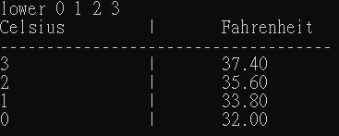
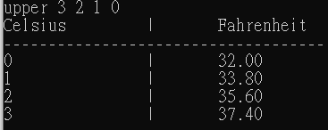
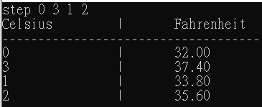
Problem 3：
Code
1. #include <iostream>
2. #include <algorithm>
3. using namespace std;
4.
5. int main(){
6. string num,renum;
7. cout<<"Enter any number: ";
8. cin>>num;
9. renum = num; //將num複製給renum
10. reverse(renum.begin(),renum.end()); //將renum反轉，此時renum即num的反轉
11. if(num == renum) //一個字串反轉後跟原來一樣，那就是迴文
12. cout<<"Given number is a palindromic number";
13. else
14. cout<<"Given number is not a palindromic number";
15. }
16.
Output
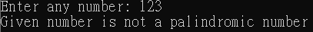
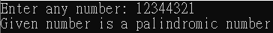

Problem 3：
Code
1. #include <iostream>
2. using namespace std;
3. const float minn = 0.00001;
4. int dp[10];
5. int DP(int i){
6. if(dp[i]) return dp[i];
7. else{
8. dp[i] = DP(i-1)*i;
9. return dp[i];
10. }
11. }
12. float pow(float x,int y){
13. float ans=1;
14. for(int i=0;i<y;i++){
15. ans*=x;
16. }
17. return ans;
18. }
19. int main(){
20. for(int i=0;i<10;i++) dp[i]=0; //reset the array
21. dp[0]=1;
22. dp[1]=1;
23. float x,e=1,lnn=0,lnp=0,tem=1; //e is e^x(and start to 1),lnn is ln(1-x),lnp is ln(1+x)
24. cin>>x;
25. int i=1; //e's Maclaurin series start to 1
26. while(tem>minn){
27. tem = pow(x,i)/DP(i);
28. e+=tem;
29. i++;
30. }
31. cout<<"e^"<<x<<" \t\t= "<<e<<endl;
32. tem = 1,i = 1; //avoid stoping program
33. while(tem>minn){
34. tem = pow(x,i)/i;
35. lnn-=tem;
36. i++;
37. }
38. cout<<"ln(1-"<<x<<") \t= "<<lnn<<endl;
39. tem = 1,i = 1;
40. while(tem>minn){
41. if((i+1)&1) //(i+1) and 1 等價 (i+1) mod 2
42. tem = (-1)*pow(x,i)/i;
43. else
44. tem = pow(x,i)/i;
45. lnp+=tem;
46. i++;
47. tem = tem>0? tem:(-1)*tem;
48. }
49. cout<<"ln(1+"<<x<<")\t= "<<lnp;
50. }
51.
Output
